
Math 30-2 -- Unit 1: Set Theory Name: Shekina
Assignment
Total: / 28 Marks

Multiple Choice and Numerical Response: Please record the best solution below each question.

- Which statement is true?

A. B.

C. D.
- Which Venn diagram correctly represents the situation described? Rahim described the set as follows:
M = {all of the foods he eats}
D = {his favourite desserts}
V = {his favourite vegetables}
F = {his favourite fruits}
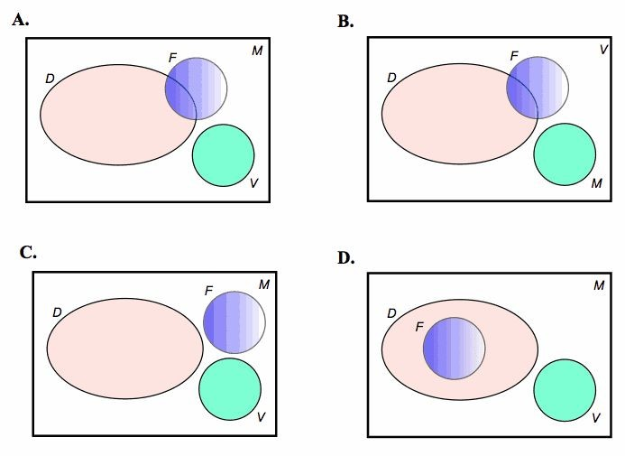
Assume Rahim always has fruit for dessert.

ANSWER. B

- There are 28 students in Mr. Connelly's Grade 12 mathematics class. The number of students in the yearbook club and the number of students on student council are shown in the Venn diagram. Use the diagram to answer the following questions.
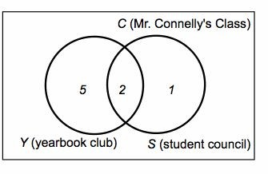
How many students are NOT in yearbook club or student council?

A. 7 B. 8 C. 20 D. 22
- Consider the following Venn diagram of herbivores and carnivores:
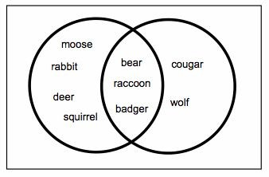
Determine .

  - {moose, rabbit, deer, squirrel}
  - {bear, raccoon, badger}
  - {cougar, wolf}
  - {moose, rabbit, deer, squirrel, bear, raccoon, badger, cougar, wolf}

- Consider the following two sets:

C = {-10, -8, -6, -4, -2, 0, 2, 4, 6, 8, 10}
B = {-9, -6, -3, 0, 3, 6, 9, 12}

Determine the number of elements in .

A. 3 B. 8 C. 11 D. 19

- A summer camp offers canoeing, rock climbing, and archery. The following Venn diagram shows the types of activities the campers like.
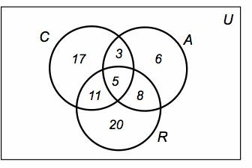

Use the diagram to determine the number of campers in .

- 64
- 48
- 37
- 59

- Tania recorded the 16 possible sums that can occur when you roll two four-sided fair dice.

S = {all possible sums}

L = {all sums less than 4}
G ={all sums greater than 4}
F = {all sums equal to 4}

Describe the relationship between sets L and G.

  - L and G are complements B. L is a subset of G
C. G is a subset of L D. L and G are disjoint

Use the following information to answer the next question.

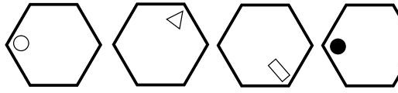

- Which of the hexagons below will continue the above sequence?
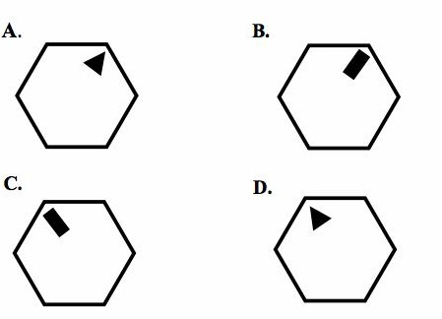

ANSWER. A

- What is the answer if, from the numbers below, you multiply by five the number of even numbers that are immediately followed by an odd number.

4 7 8 5 3 1 9 7 8 4 4 7 8 9 2 3

A. 25 B. 15 C. 5 D. 3

- What does the shaded region represent?
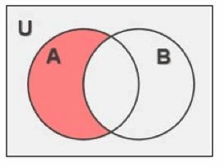

A.
B.
C.
D.

Written Response: Show all necessary work to obtain full marks.

1. Give an example of two sets where one is a subset of the other. (1 mark)

A = {1, 2, 3, 4}
B = {1, 2, 3, 4, 5}
Every element in A is in B.
So, A is a subset of B
i.e AB
2 a. Provide an example of two sets, A and B where . (1 mark)

A = {1, 3, 6}
B = {9, 11, 13}
AB = $∅$
b. Explain your reasoning for choosing sets A and B. (1 mark)

Sets A and B are disjoint sets. Disjoint sets are sets that have no elements in common. The intersection of disjoint sets is an empty set.

- Mrs. Lam's physics class is visiting the local amusement park. She has 32 students. Of these students, 20 plan to ride the roller coaster and 15 plan to ride the vertical drop. There are 8 students who do not plan to ride either attraction.

- Organize your information in a Venn diagram. (1 mark)
RC
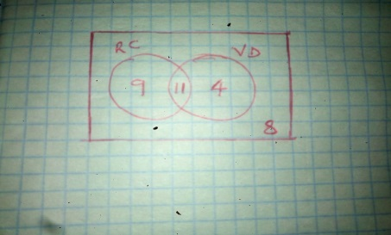
VD
11

8
4
9

- Determine how many students plan to ride both the roller coaster and the vertical drop. (1 mark)

Let the number of students plan to ride both the roller coaster and the vertical drop be x,
20 + 15 – x = 32 – 8
35 – x = 24
x = 35 – 24
x = 11
- Write your answer in set notation. (1 mark)
Let R represent the roller coaster and V the vertical drop

n[RV]

- Grade 12 students were surveyed about their extra-curricular activities.

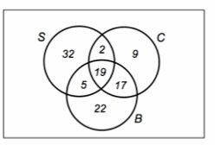

●
  - 58 belonged to a sports team (S)
  - 63 belonged to a band or choir (B)
  - 47 belonged to a school club (C)
  - 24 belonged to a sports team and a band or choir
  - 21 belonged to a sports team and a school club
  - 36 belonged to a band or choir and a school club
  - 19 engaged in all three activities
●
●
On the above diagram, shade the region of students that only belong to a band or choir. (1 mark)

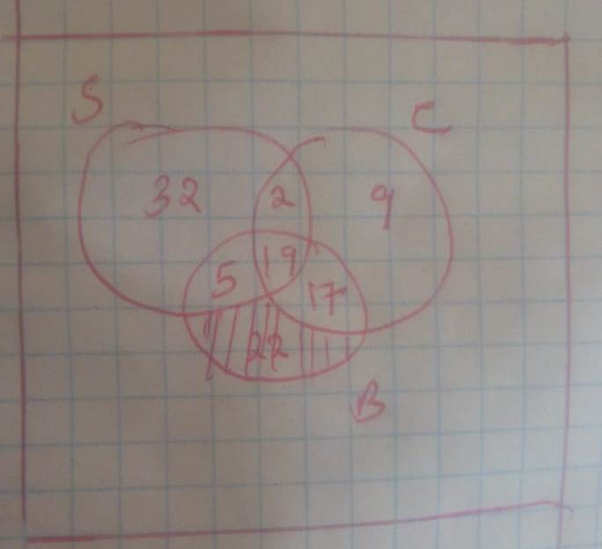

- The city surveyed 3000 people about how they travel to work.

  - 3000 people surveyed
  - 1978 took public transit (P)
  - 1494 drove (D)
  - 731 took public transit and drove only
●
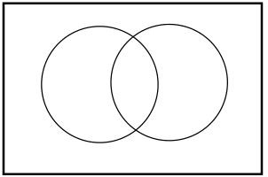
P
D
259
731
763
1247

  - a. How many people travel to work some other way? Use a Venn diagram to show your answer.

(2 marks)

Let the number of people who travel to work some other way be x,
1247 + 763 – x = 3000 - 731
2010 – x = 2269
x = 2269 - 2010
x = 259

  - b. How would you write this answer using set notation. (1 mark)

n[P^{c}D^{c}]

- A total of 83 teens attended a performing arts camp to train in at least one of three activities: dance, acting, or singing.

47 took dance, 42 took acting, and 54 took singing. 3 took dance and acting only.
16 took acting and singing only. 9 took dance and singing only.

How many teens trained in all three performing arts? (3 marks)
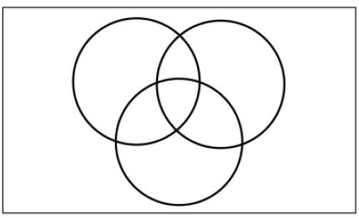
13
19
7
16
9
16
3
S
A
D

Let the number of teens trained in all three performing arts be x;
Singing, S: 54-9-16-x
29 - x
Dancing, D: 47-9-3-x
35 - x
Acting, A: 42-16-3-x
23 – x
83 = 35 – x + 9 +3 + x + 16 + (29 – x) + (23 – x)
83 = 115 – 2x
2x = 16
x = 16

- In the supermarket, the aisles are numbered one to six from the entrance. Washing powder is next to bottles and it is not the first item you seen when entering the supermarket. You will see the meat aisle before the bread aisle. Tins are two aisles before bottles and meat is four aisles after fruit.

  - What is in aisle six? (1 mark)
Bread
  - In which aisle can bottles be found? (1 mark)
●
● Bottles

  - Explain the strategy you used to solve this puzzle. (1 mark)
●
● Washing powder comes before bottles
●
  - Create a variation of this puzzle and provide an answer key for your variation. (2 marks)
● There is no enough information.

